What is a Technological System?

It is something designed by people for a purpose. Technological systems are like a ‘team’ - the parts work together to change an input to an output.

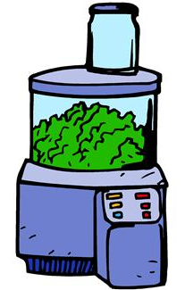
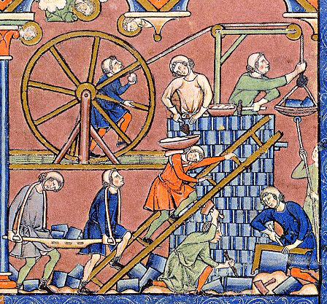

What is this? What makes it work? (input)

What if we don’t know exactly what is happening in a system? Is this a good thing?

Do we need to know everything that is
happening in a system?

What is happening when a switch
or button is pushed? (output)
What is the change that happens?

